*INSURANCE PORTAL*

1. Hit Page which shows Insurance Portal home page

***HOME:*** It displays the Home Page.

***ABOUT US:*** It displays the About Us.

***SITEMAP:*** It displays the Site Map.

**CONTACT US:** It displays the Contact Us details.

**MOTOR INSURANCE: Drop Down**

1. ***Car Insurance:***

**🡺** *Renew Car Insurance Policy*

* *Call indirect Login tab -> signup and -> New Register user*

**🡺** *Insure Brand New Car*

* *Call indirect Login tab -> signup and -> New Register user*

1. ***Bike Insurance:***

*Same as Car Insurance*

**LOGIN:**

1. ***Login Page:*** It contains Username Password, Role and Forgot Password.
2. ***Registration Page:*** First Name, Middle Name, Last Name, DOB, email Id, Phone Number.

**New User Page:**

*Profile, Choose Plan, and Buy Plan, Request Call Back.*

**Existing User Page:**

*Profile, Claim, Renewal, Track Status*

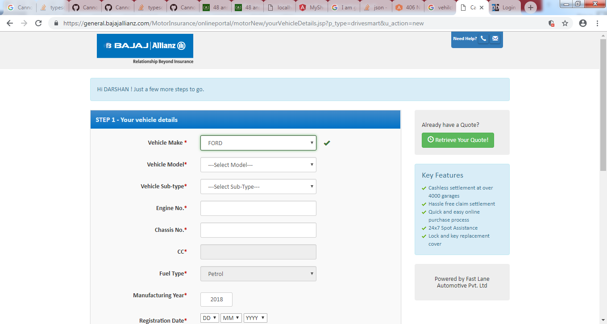

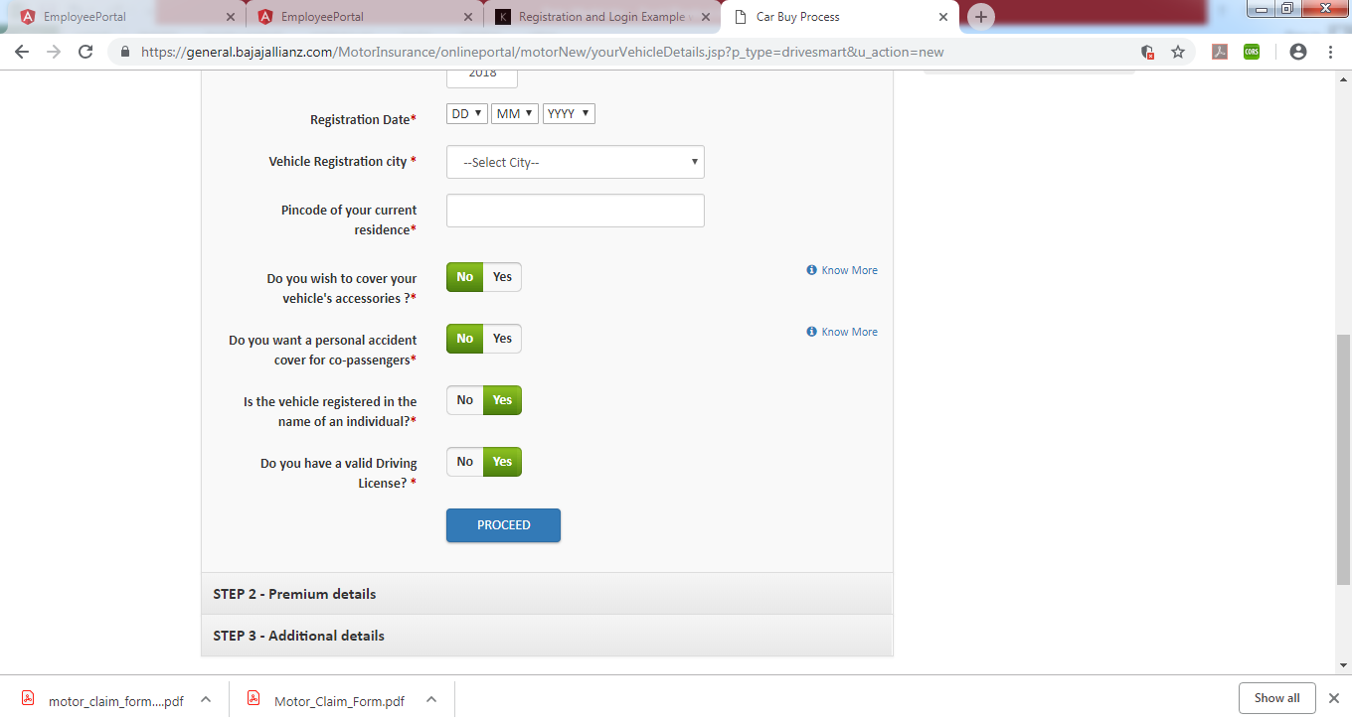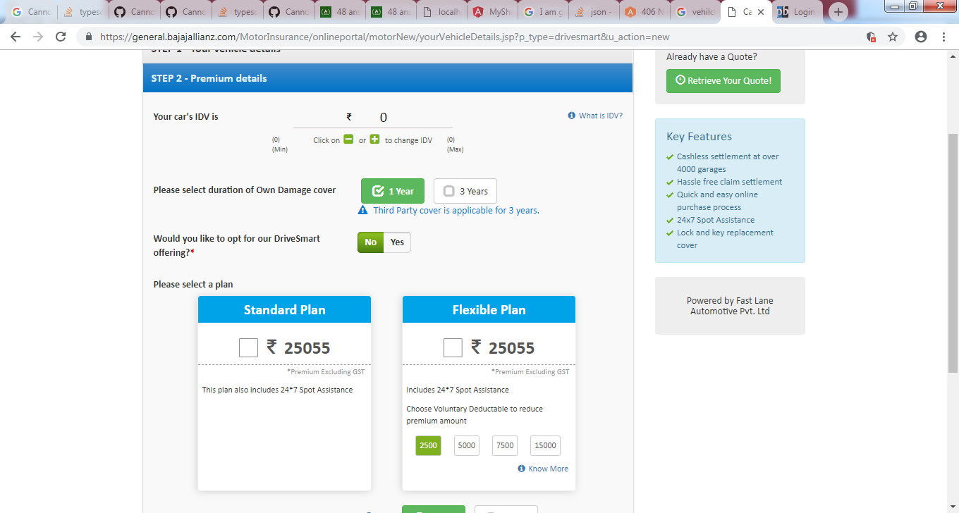

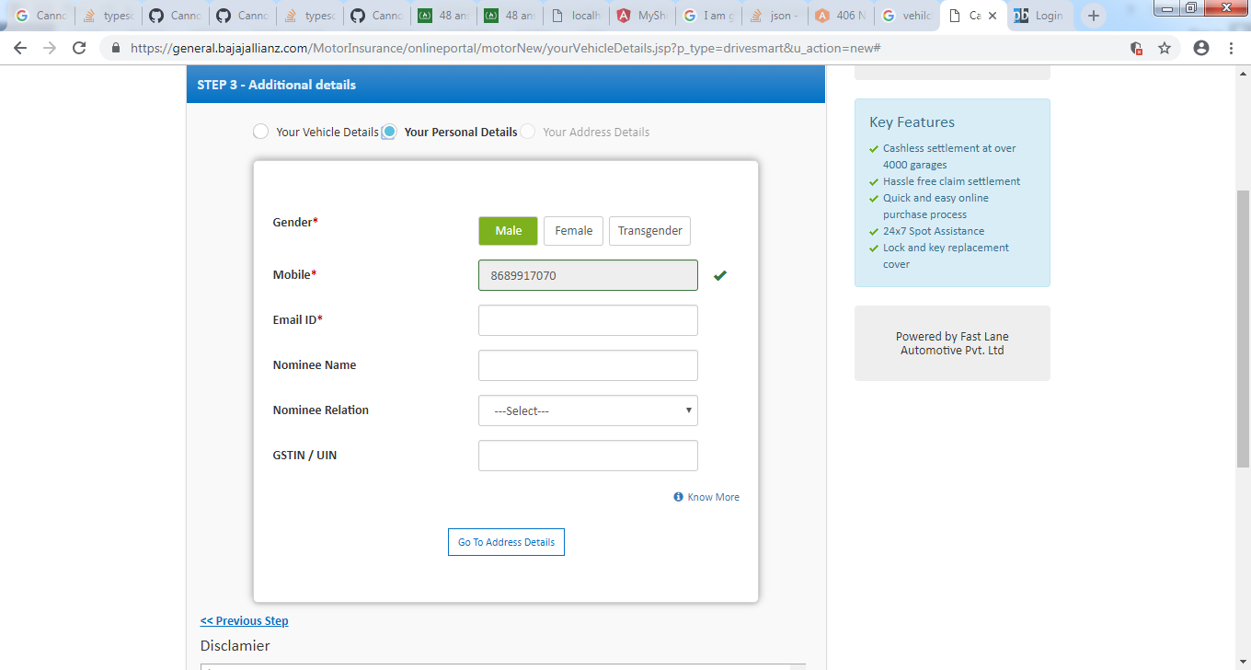 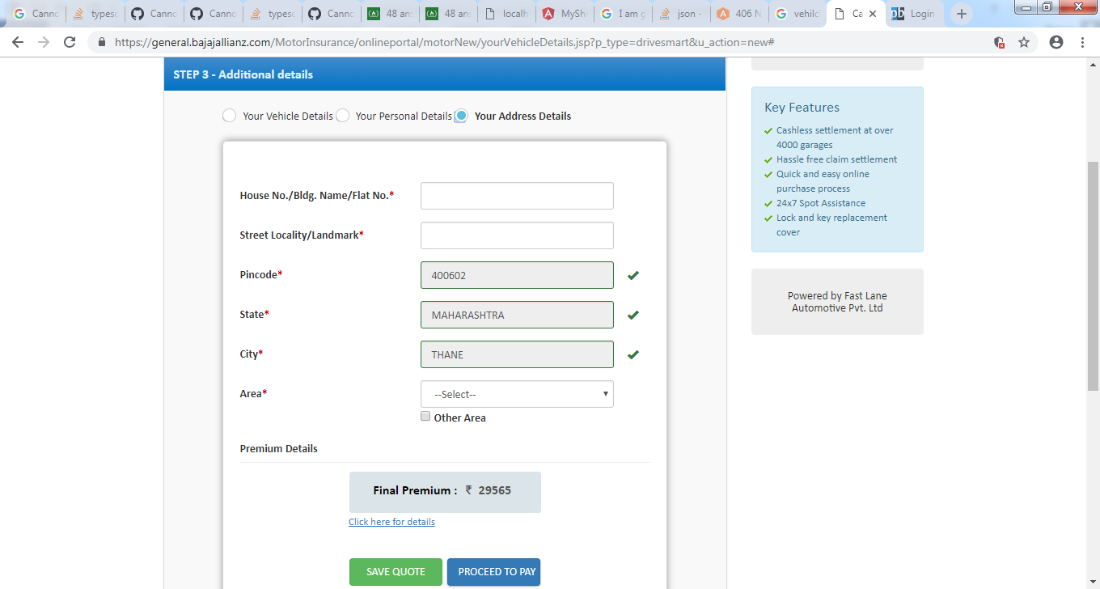 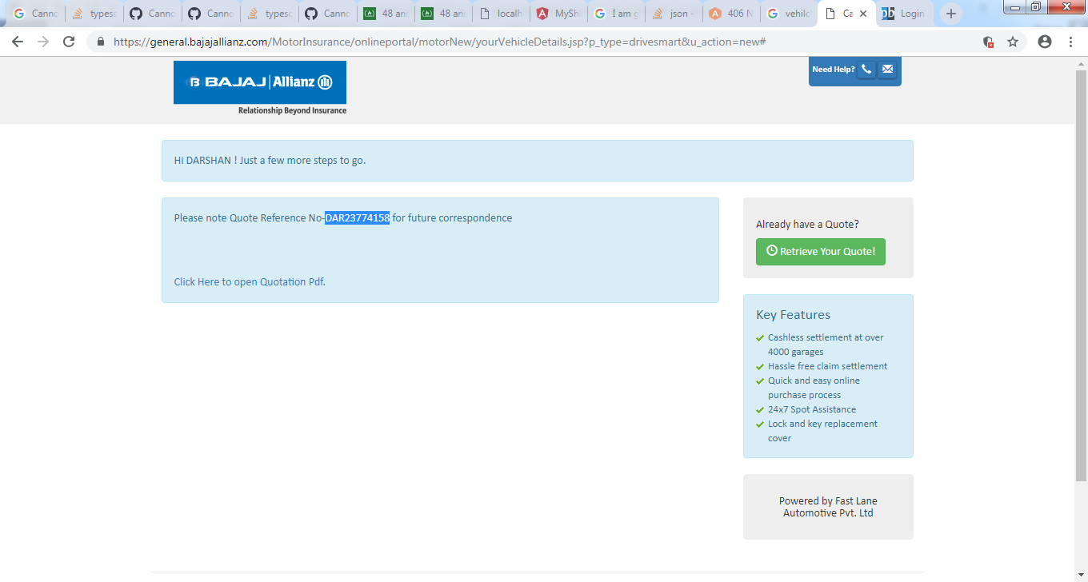 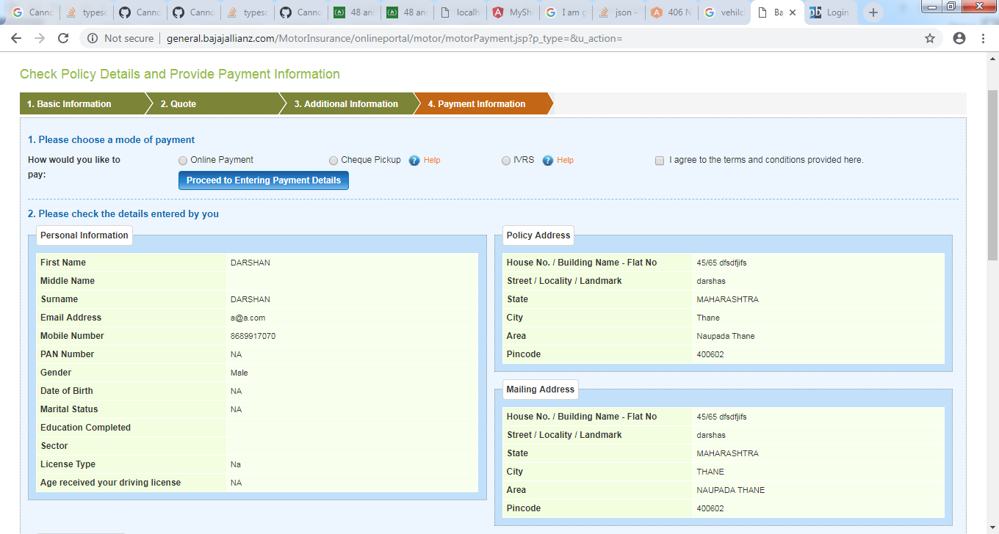 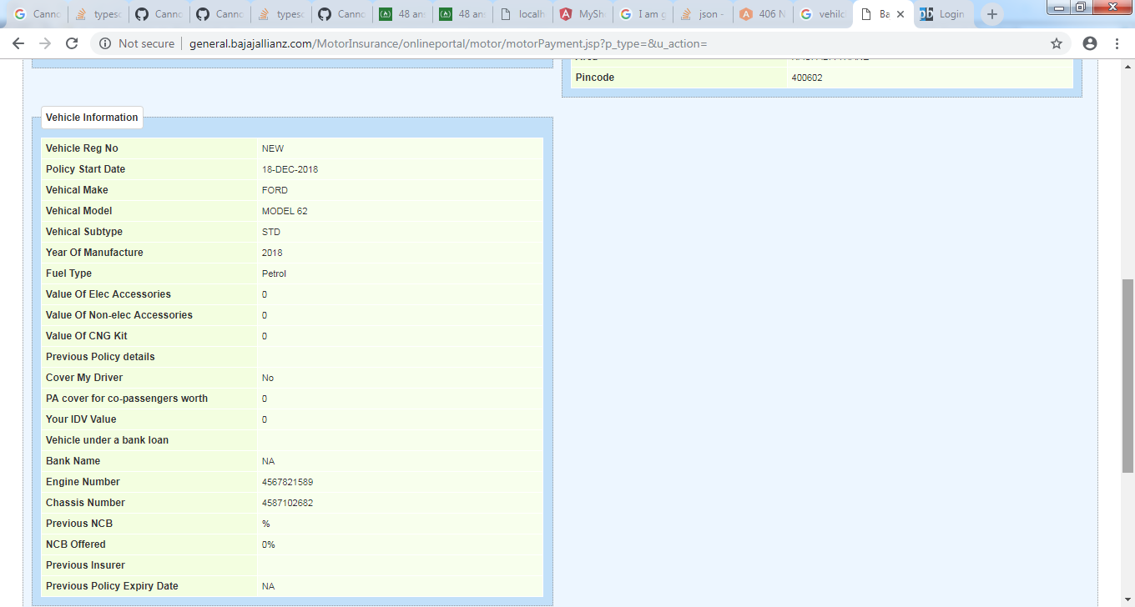 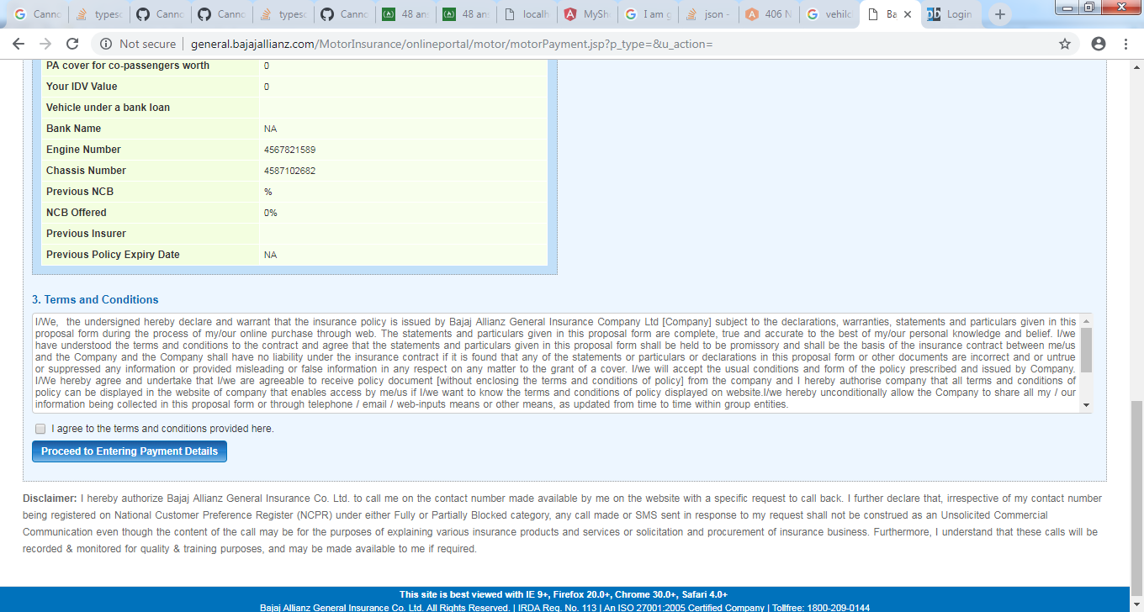

Login page

